Title of the paper in English
Titre du document en Français
A. N. Corresponding / primary author
Institution/Company/University, City, Country
A. N. Other author, A.N. additional authors (from same institution)
Institution/Company/University, City, Country
A. N. Other author
Institution/Company/University, City, Country

ABSTRACT: This template illustrates the format that must be used in the preparation of full papers for the XVII European Conference on Soil Mechanics and Geotechnical Engineering. Papers are to be submitted in English or Frence based on the original abstract submitted. All manuscripts must be prepared electronically and submitted in accordance with the following instructions using the online submission feature provided on the conference web site. Lorem ipsum dolor sit amet, ne meis aeterno necessitatibus mei, te eum quando cetero nostr um, per justo utroque omittam eu. Modo assentior has in, utamur aliquip admodum duo in, sit natum mediocrem at. Aliquid definiebas no has, nam justo malis simul at, ridens invidunt duo eu. Eam id dolore verear delicata, vis phaedrum deseruisse adipiscing ut.

RÉSUMÉ: Résumé en Français, Ce modèle illustre le format à utiliser pour la préparation de documents complets pour la XVIIe Conférence européenne sur la mécanique des sols et l’ingénierie géotechnique. Les articles doivent être soumis en anglais ou en français sur la base du résumé original soumis. Tous les manuscrits doivent être préparés électroniquement et soumis conformément aux instructions suivantes en utilisant la fonction de soumission en ligne fournie sur le site Web de la conférence. Voyons ce que beaucoup de cela dans mes mes besoins de toute éternité, vous lui quand le reste de la nôtre, à travers les justes, à la fois parler de football. Maintenant, je suis d'accord avec ceux-ci, nous utilisons certains très deux, est lié à modérée, cependant.

Keywords: Keywords should use Times New Roman 10 pt. font; separated by semicolon; Maximum 5

guidelines
Please read this text before you start preparing your paper for the proceedings of the ECSMGE-2019. The purpose of this guideline is not only to clarify a few points but also to stress that it is imperative that everyone complies exactly with the instructions and use the official format which will be available on the conference website in order for the proceedings to be of the highest quality and to be published on time.
Some printers may print the file single-sided or may not print due to the custom paper size. This is a function of Word and saving the file as a PDF before printing will resolve most issues. Please do not change the page size or format of the submitted document: make a temporary copy if you need to change the paper size for printing.

Publication and submission
Submission of full papers will be due October 30th, 2018. Paper submissions must be a electronic copy of a Microsoft Word Document, submitted contribution should include the MS-doc or docx as well as the PDF file of the paper.
The proceedings will be published in digital format only. Submitted papers shall not be longer than 8 pages and maximum size 8 Mb.
The full-length of standard papers will be published in digital format only. Papers will be published in free and open access in the ISSMGE Online Library and indexed with their own individual DOI number. Papers will also be online at conference website.

Figure 1. ISSMGE Online Library logo

Language
The paper may be written in either English or in French. The title of the paper should be given in both English and in French, with the title in the language of the paper appearing first.
The abstract of the paper should be given in both English and French, with the abstract in the language of the paper appearing first.
The paper will be expected to be a complete treatment and presentation, with all the usual elements of a self-contained scientific or technical paper. It should comply in structure and layout with the instructions given below.

Material
Contributions are accepted on the understanding that the paper is original and has not been published before.

File name
aaaa-ecsmge-2019_xxxxx.docx/.doc
aaaa-ecsmge-2019_xxxxx.pdf
were following is:
aaaa the abstract number
xxx the main/ presenting authors last name

example: 0524-ecsmge-2019_Lastname.docx
0524-ecsmge-2019_Lastname.pdf

Text Format
Please note that the layout of all sections that appear after the abstract have to be double-column. This means that only the double column layout is acceptable for publication. The two columns of text on the last page of each paper must be balanced (that is, adjusted to have the same vertical extent; use the column break to achieve this).

Type area and page size
Do not amend the margin settings or page dimension within the template. These are as follows:
246 x 189 mm page size:
Top 2.8 cm
Bottom 2.0 cm
Left 1.6 cm
Right 1.5 cm

Structure
Please adhere to the following order of presentation: Title, Author(s), Affiliation(s), Abstract, Main text, Conclusion, Acknowledgement, References.
The title should be written as a sentence, so NO capital letters where they would not usually appear. And no full stop (“.”) at the end of the title.
For example: Remote sensing for monitoring the changing landscapes (Not: Remote Sensing for Monitoring the Changing Landscapes.)

Author(s)
Author should start with the Initial(s) and then the Family name,. For example: I. Newton, J. Lewis & M.E. Jansen

Titles
Titles or occupation (such as Prof., dr., eng. PhD etc) are NOT permitted, only in the main text titles will be allowed.

Corresponding author(s)
The name, title, postal address, telephone number and e-mail address of the corresponding author should be given via the online submission system.

Abstract
The abstract should be readily understandable to most readers and may contain up to 250 words. Use the full typewidth of the page (single column).

Text
The text should be in 11 pt Times New Roman for the body of the text. The indent must be 0.5 cm. The text for reference section is in 10 pt Times New Roman. Symbols should be in italics and SI (international system) units must be used throughout the whole text.
For the text, a maximum of three levels of sections and subsections is allowed.
Eg. 1. Introduction
1.1 Europe
1.1.1 History
1.1.2 Future
1.2 Asia
1.1.1 History
1.1.2 Future

Headings
Headings 1 and 2 should be in 12 pt Times New Roman, italics, only capital letters for heading level 1.
It is important to reproduce the spacing of the text and headings as shown here. Text should be single spaced.

Figures and tables
Figures are allowed to fill either one or two columns, and must be accompanied by a caption below. Colour figures are accepted.
The caption should be in 10 pt Times New Roman, italics. The figure and corresponding caption must be placed in a text box if the figure exceeds one column.
The resolution of the figures must be at least 300 dpi, and the applied text should be in 9 pt.

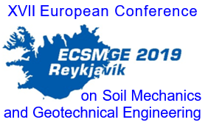

Figure 2. Sample

Tables follow the instructions for figures, with the addition that the headers should be in bold.

Table 1. Sample (use 10 pt both in heading and table)
Heading | Sub 1.1 | Sub 1.2
Sub 2.1 | 1 | 4
Sub 2.1 | 2 | 5
Sub 2.1 | 3 | 5

The reference to figures and tables should be referred to as Figure 1 and Table 1, respectively. Figures and tables should be numbered consecutively.

Equations
Samples of equations are given below and each equation should be numbered consecutively, refer to equations by these numbers.
Use the equation editor of the selected word processing program and the text 11 pt. The layout should be standard "professional" in WORD.
All symbols should be in italics. Indent is 0.5 cm for equations and an empty line must be placed above and below equations.
The used parameters must be described below equations, and unit should be given in parentheses.

$e^{z}=q^{'}∙K_{q}^{z}+c∙K_{c}^{z}$ (1)

$K_{q}^{z}=\frac{{K_{q}^{0}+K_{q}^{∞}∙α}_{q}∙\frac{z}{B}}{1+α_{q}∙\frac{z}{B}}$ (2)

$α_{q}=\frac{K_{q}^{0}}{K_{q}^{∞}-K_{q}^{0}}∙\frac{K_{0}∙\sin{φ}}{\sin\left(45+0,5∙φ\right)}$ (3)

Where $e^{z}$ (kPa) is earth pressure at depth z (m), etc.

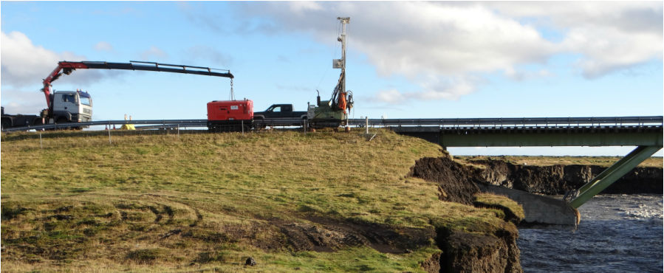
Figur 3 Figures, tables and graphs are allowed to fill either one or two columns,

References
References to the literature should be mentioned in the main text by stating the surname of the cited author followed by year of publication, all contained in rounded brackets

Conclusions
Conclusions should state concisely the most important propositions of the paper as well as the author’s views of the practical implications of the results.

ACKNOWLEDGEMENTS
The first paragraph, aliquid definiebas no has, nam justo malis simul at, ridens invidunt

References
Last name, First name or Initials (ed.) year. Book title. City: Publisher.
Last name, First name or Initials year. Title of article. Title of Journal (series number if necessary) volume number (issue number if necessary): page numbers.
Author, A.N. 1995. Book Title, Publisher Name, Publisher Location.
Author, A.N. 2004. Article title, Journal Title 20, 1012–1030.
Author, A.N., Author, A.N. 2004. Article title, Journal Title 20, 102–130.
Author, A.N. Author, A.N., Author, A.N. 2012. Article title, Journal Title 12, 12–19.
Author, A.N., Author, A.N. 2010. Paper title. Active Geotechnics: Proceedings, 12th INGA Congress (Eds: Smith, A.L., Bloggs, G.M. & Nobody, A.), 1002-1005. Publisher Name, Publisher Location.

