The effect of loading frequency on the resilient modulus behaviour of non-engineered Mudrock backfill materials

Effet de la fréquence sur le Resilient Modulus de
matériaux en Mudrock
S. Kennedy
University of Sheffield, Sheffield, UK
Dr S. D. Clarke, Dr P. Shepley
University of Sheffield, Sheffield, UK

ABSTRACT: The planned High Speed rail 2 (HS2) route in the UK is expected to pass through South Yorkshire. Mudrock colliery backfill covers a widespread area. In this paper the performance of a subsoil subjected to different load frequencies were studied. The material of study is mudrock backfill, a weak prevalent rock which response under indicative loading of high speed rail line is unknown. A triaxial cyclic loading machine was conducted to assess the expected mechanical behaviour of mudrock under a range of dynamic loads which could be generated beneath different track constructions. In this paper the material of study was compacted at the optimum moisture content or in a fully saturated condition and subjected to cyclic loading. Two different load frequencies are applied to recreate in situ conditions in the laboratory by applying 4 and 1 Hz frequencies. The performance of the railway track is based on the interaction between the subgrade and superstructure. Thus, appropriate track support is important for both ride quality and to reduce track and vehicle maintenance costs. To reduce maintenance costs a better understanding of the properties of the supporting soil (which includes both prepared soil and in situ conditions) are required. The resilient modulus or stiffness is an important parameter for the characterization of the supporting soil, and to assess the suitability of such material to resist this kind of cyclic loading.

RÉSUMÉ: La ligne de chemin de fer à grande vitesse 2 (HS2) au Royaume-Uni traverse le sud du Yorkshire. Le remblai de Mudrock couvrait une vaste zone étendue. Dans cet article, les performances du sous-sol soumis à différentes fréquences de charge ont été étudiées. Le matériau à étudier est le remblai de Mudrock, un rocher dominant faible, dont la réponse sous chargement indicatif d'une ligne de chemin de fer à grande vitesse est inconnue. Une machine à chargement cyclique triaxial a été réalisée pour évaluer le comportement mécanique attendu du Mudrock sous une plage de charges dynamiques pouvant être générées sous différentes constructions de voie. Dans ce papier matériau d'étude compacté à la teneur en humidité optimale ou saturé et soumis à une charge cyclique. Deux fréquences de charge différentes sont appliquées pour recréer les conditions in situ en laboratoire en appliquant des fréquences de 4 et 1 Hz. La réponse cyclique est essentielle pour déterminer la déformation plastique résiduelle qui est la principale préoccupation pour connaître le taux de tassement.

Keywords: Resilient modulus; Mudrock; load frequency; particle breakage; high speed rail.

Introduction
Foundation subsoils are commonly exposed to dynamic stress changes during their service lifetime. These stresses are known to cause an increase in deformations in the soil. The sources for these loads could cause form seismic activity, passing traffic or vibrating machinery during construction. Some cyclic loadings are known to generate a waveform in the soil, which depends on the load source. In railway systems the waveform that exists is of a single frequency which is dependent on train speed. This cyclic loading needs advanced test systems in order to simulate the situ situation of soil under such load. In this research Mudrock colliery spoil is the material of study. Mudrock is a prevalent rock in the UK and is composed of argillaceous sediments which are classified according to the proportion of particle size of claystone, shale, mudstone, siltstone and coal. Cripps & Taylor (1981) found that weathering causes changing the properties of indurated rock from very strong to softening and breakdown bonds due to the development of the deformability.
Studying the stiffness of soil is an important factor in engineering and allows the deflection in the layers beneath the track to be predicted. This can be quantified by the measurement of the elastic stiffness of the subsoil under different loading conditions as shows in equation below:

$Mr=\frac{Δσ_{d}}{Δε_{r}}$ (1)

Where Mr is the resilient modulus, Δσ_{d} is the deviatoric stress and Δε_{r} is the residual strain.

This paper focuses on the effect of cyclic stress on the resilient modulus for mudrock. Many studies have been done to evaluate the effect of load frequency to the stiffness of friable soils. Fairhurst, et al. (1990) and Taherkhani et al. (2017) indicated in their studies that the Mr increases with an increase in the loading frequency.

Physical properties of soil
The material of study, mudrock colliery spoil, was collected from Kellingley Colliery on the 10th of August 2015. The material used in this study is dark grey Mudrock colliery spoil and has a varied particles size. Figure 1 shows the particle size distribution for material pass through 10 mm size, which is classified as well-graded. The Mudrock was compacted by traditional compaction methods to find the optimum moisture content and maximum dry density and the result in Figure 2.
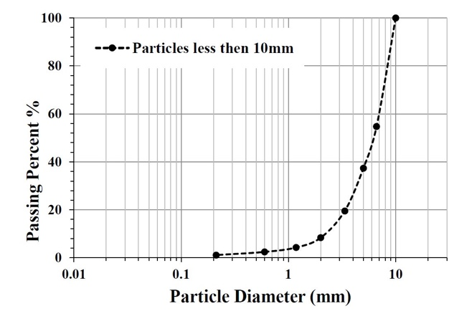Figure 1. Particle size distribution for Mudrock

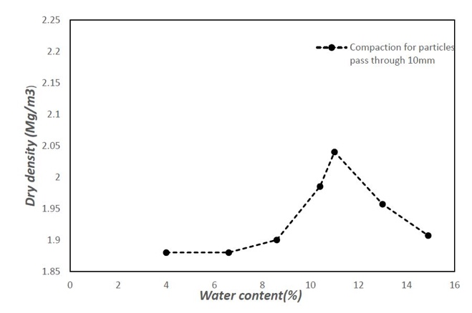Figure 2. Compaction results for Mudrock colliery spoil
specific gravity for this material is 2.75. Slaking test has been conducted and it can be classified as having medium slake durability according of the classification of Franklin and Chandra (1972)

Test procedure
In this paper, a cyclic triaxial apparatus manufactured by Wykeham Farrance was used for the experimental testing to investigate the dynamic response of Mudrock samples. In the tests described in this paper 40 kN/m² of vertical stress, 18 kN/m² of confining pressure and 20 kN/m² of cyclic load were applied. Two different frequencies of 1 and 4 Hz were tested to assess the effect of frequency under three different saturation cases (dry, partial saturated at optimum moisture content and fully saturated). In the test series between 3x10⁵ and 1x10⁶ cycles were applied. Due to the nature of the data logging, the resilient modulus was plotted for each of the first 100 cycles and then at the end of each 10⁵ cycles till then end of the test. For the frequency of 4 Hz each data point represents the average of 5 cycles, for the 1 Hz test each data point represents a single cycle. The axle load considered in this study is that of the British acceptable load, 125 kN. The characteristic of actual dynamic load, confining pressure and initial axial stress were assumed on specimen 20 kN/m³ , 18 kN/m³ The initial stress has been calculated assuming a density of 2.14 Mg/m3. All specimens have been tested under drained conditions due to the long duration of the tests. In the partially saturated and dry tests, the pressure inside the system was kept equal to the atmospheric pressure by keeping the valve connected to the atmosphere open and shutting off the valve connected to the back pressure chamber. In the saturated condition the valve to the water source of back pressure was kept open, in this case the pore water was allowed to freely drain during loading. The 40 kPa cyclic stress that applied during test has been calculate at 1 m depth according to the literature review that found in Powrie et al ,2007. In ideal conditions repeated tests are required to be able to accurately assess any given material. With the current test programme having many possible variables and each test being a long duration test to in 10⁶ cycles, it was critical that the requirement for repeats could be eliminated. Hence, repeated test were conducted for partial saturated test conditions under triaxial cyclic loading. the specimens behave almost identically in terms of resilient modulus.

Load frequency
Load frequency plays an important role on the influence of the cyclic stress and cumulative strain and hence the behaviour of the subgrade soil under track. The load frequency of moving train depends upon the train speed, carriage length, number of bogies and axle distance. In the UK transportation pattern high speed railway (HS1) trains run at speed between 230 km/h (143 mph) to 300 km/h (186 mph) with length 108 m. In this study load frequencies of 1 and 4 Hz were used for testing and are indicative of the frequencies induced by HS1.

Result and Analyses
Figure 3 presents a semi-log plot of the effect of varying saturation conditions on the resilient modulus. In the saturated state, the resilient modulus under repeated loading increase slightly with increase number of cycles and then start to fluctuate after 16 cycles, it can be attributed to the breakage of particles. Afterward increase linearly with increase number of cycles then to reduce after 3x10⁵ cycles. It could be argued that is influenced the response of deformation, as well as causing a reduction in both strength and resilient modulus and development of pore water pressure (Dawson et al., 1996). The partially-saturated sample shows a higher resilient modulus which increases linearly then decreases at 3x10⁵ cycles. The resilient modulus for the dry condition shows an increase linearly with increase number of cycles. In the dry case the particles are more likely to rearrange due to permanent slips which occur at the contacts between particles and permanent dislocation of particles leading to unrecoverable strain.
Figure 4 shows the results of the same tests conducted at 1 Hz to find the effect of frequency on the response. The results in this figure show that the resilient modulus for saturated increase slightly and steady with increase number of cycles to reach the equilibrium at 100 cycles, and then decrease slightly up to 3x10⁵ cycles. The partially-saturated sample increases linearly to reach to the equilibrium increment at 100 cycles. Dry condition shows the stiffness fluctuated due to the rearrangment of particles to dropdown after 10⁵ cycles to increase afterward.

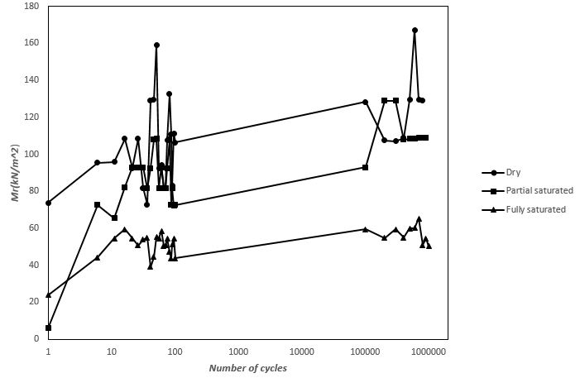
Figure 3. Resilient modulus for Mudrock under 4 Hz

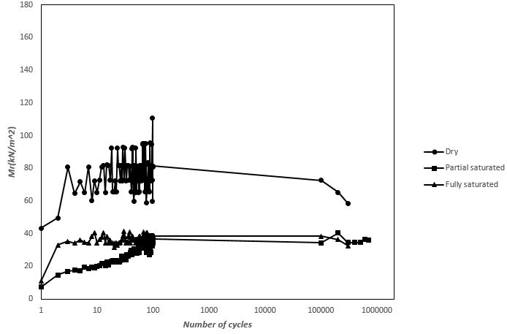
Figure 4. Resilient modulus for Mudrock under 1 Hz

The reduction of stiffness in dry condition during cyclic is attributed to replace the coarse size so that the mechanical behavior based on the fine particle. Moreover, during cyclic loading particles has ability to breakage and rearrange itself causes improvement of strength and scattering of Mr values (Hyde, 1974).
In the saturated case, the voids are mainly filled with water and the soil is likely to lose some mechanical development of strength during the loading (Duong et al., 2016).
In Figure 4 the trend of resilient modulus shows the same as shown in Figure 3 for the dry states, except that the magnitude of Mr is 20% higher in the 4 Hz test. In dry condition the structural breakage and rearrangement leading to densification of the specimens which is likely in these high number of cycle tests. This phenomenon is likely to increase the scatter for Mr due to the high frequency of the repeated load. Mr is reduced in the saturated and partially saturated specimens with a sharp decline in stiffness from the dry specimen under 1 Hz. In the 4 Hz testing the partially-saturated sample showed little reduction in modulus when compared with the dry sample.
Generally the Mr is higher at low degrees of saturation due to the lower amount of moisture causes a lubricating effect and leads to reduced friction (Thom and Brown, 1987).
There also appears to be a reduction in the sensitivity of the Mr to changes in moisture content with increasing frequency. The saturated samples under both frequencies reach the same modulus after ~100 cycles both cases.
For specimens tested under the higher cyclic frequencies there would be a shorter resting time for the loaded specimen to rebound elastically between the pulse loads. If the specimen does not rebound completely, the total recovered strain would be lower and the determined resilient modulus would be higher, as has been shown in the testing.

Conclusions
Generally an increase in the loading frequency causes an increase in the resilient modulus. The effect is tempered by the presence of water in specimens with the saturated specimens showing a much smaller increase with frequency whist showing a much lower overall modulus. The increase in frequency between 1 and 4 Hz adds ~20% to the resilient modulus in the dry and saturated cases. However, the move from dry to saturated conditions under the same frequency causes a reduction in resilient modulus of around 50%, showing the importance of assessing the realistic in-situ moisture content conditions in construction for HS2 if Mudrock colliery spoil is to be successfully used as a foundation subbase material. Variable depth will consider in future work. From the testing conducted, the long-term resilient modulus was found to increase due to: decreases in the moisture content; and increases in the loading frequency.

ACKNOWLEDGEMENTS
The corresponding author would like to thank her co-authors and Prof. William Powrie for their guidance, valuable suggestions and support during the research.

References
Cripps, J.C., Taylor, R.K. 1981. The engineering properties of mudrocks. Quarterly Journal of Engineering Geology, 14(4), 325–346.
Dawson, A.R., Thom, N.H., Paute, J.L. 1996. Mechanical characteristics of unbound granular materials as a function of condition. Gomes Correia, Balkema, Rotterdam, 35–44.
Duong, T.V., Cui, Y., Tang, A.M., Dupla, J., Canou, J., Calon, N., Robinet, A. 2016. Effects of water and fines contents on the resilient modulus of the inter layer soil of railway substructure. Acta Geotechnica, 11(1), 51–59.
Fairhurst, C.E., Kim, Y.R., Kosla, N.P., Khosla, N.P. 1990. Resilient modulus testing of asphalt specimens in accordance with ASTM D41 23–82.National academy of science.
Hyde, A.F.L. (1974) Repeated load triaxial testing of soils. PhD thesis, University of Nottingham.
Franklin, J. and Chandra, R. (1972). The slake-durability test. In International Journal of Rock Mechanics and Mining Sciences & Geomechanics Abstracts, volume 9, pages 325–328. Elsevier.

Taherkani, H., Nejad, F. 2017. Investigation the effect of temperature and loading frequency on the resilient modulus of SBS polymer modified asphalt concert in dry and saturated conditions. International Journal of Transportation Engineering, 5(1).
Thom, N., Brown, S. F. 1987. Effect of moisture on the structural performance of a crushed-limestone road base. Number 1121.

Powrie, W., Yang, L., and Clayton, C. R. (2007). Stress changes in the ground below ballasted railway track during train passage. Proceedings of the Institution of Mechanical Engineers, Part F: Journal of Rail and Rapid Transit, 221(2):247–262.

